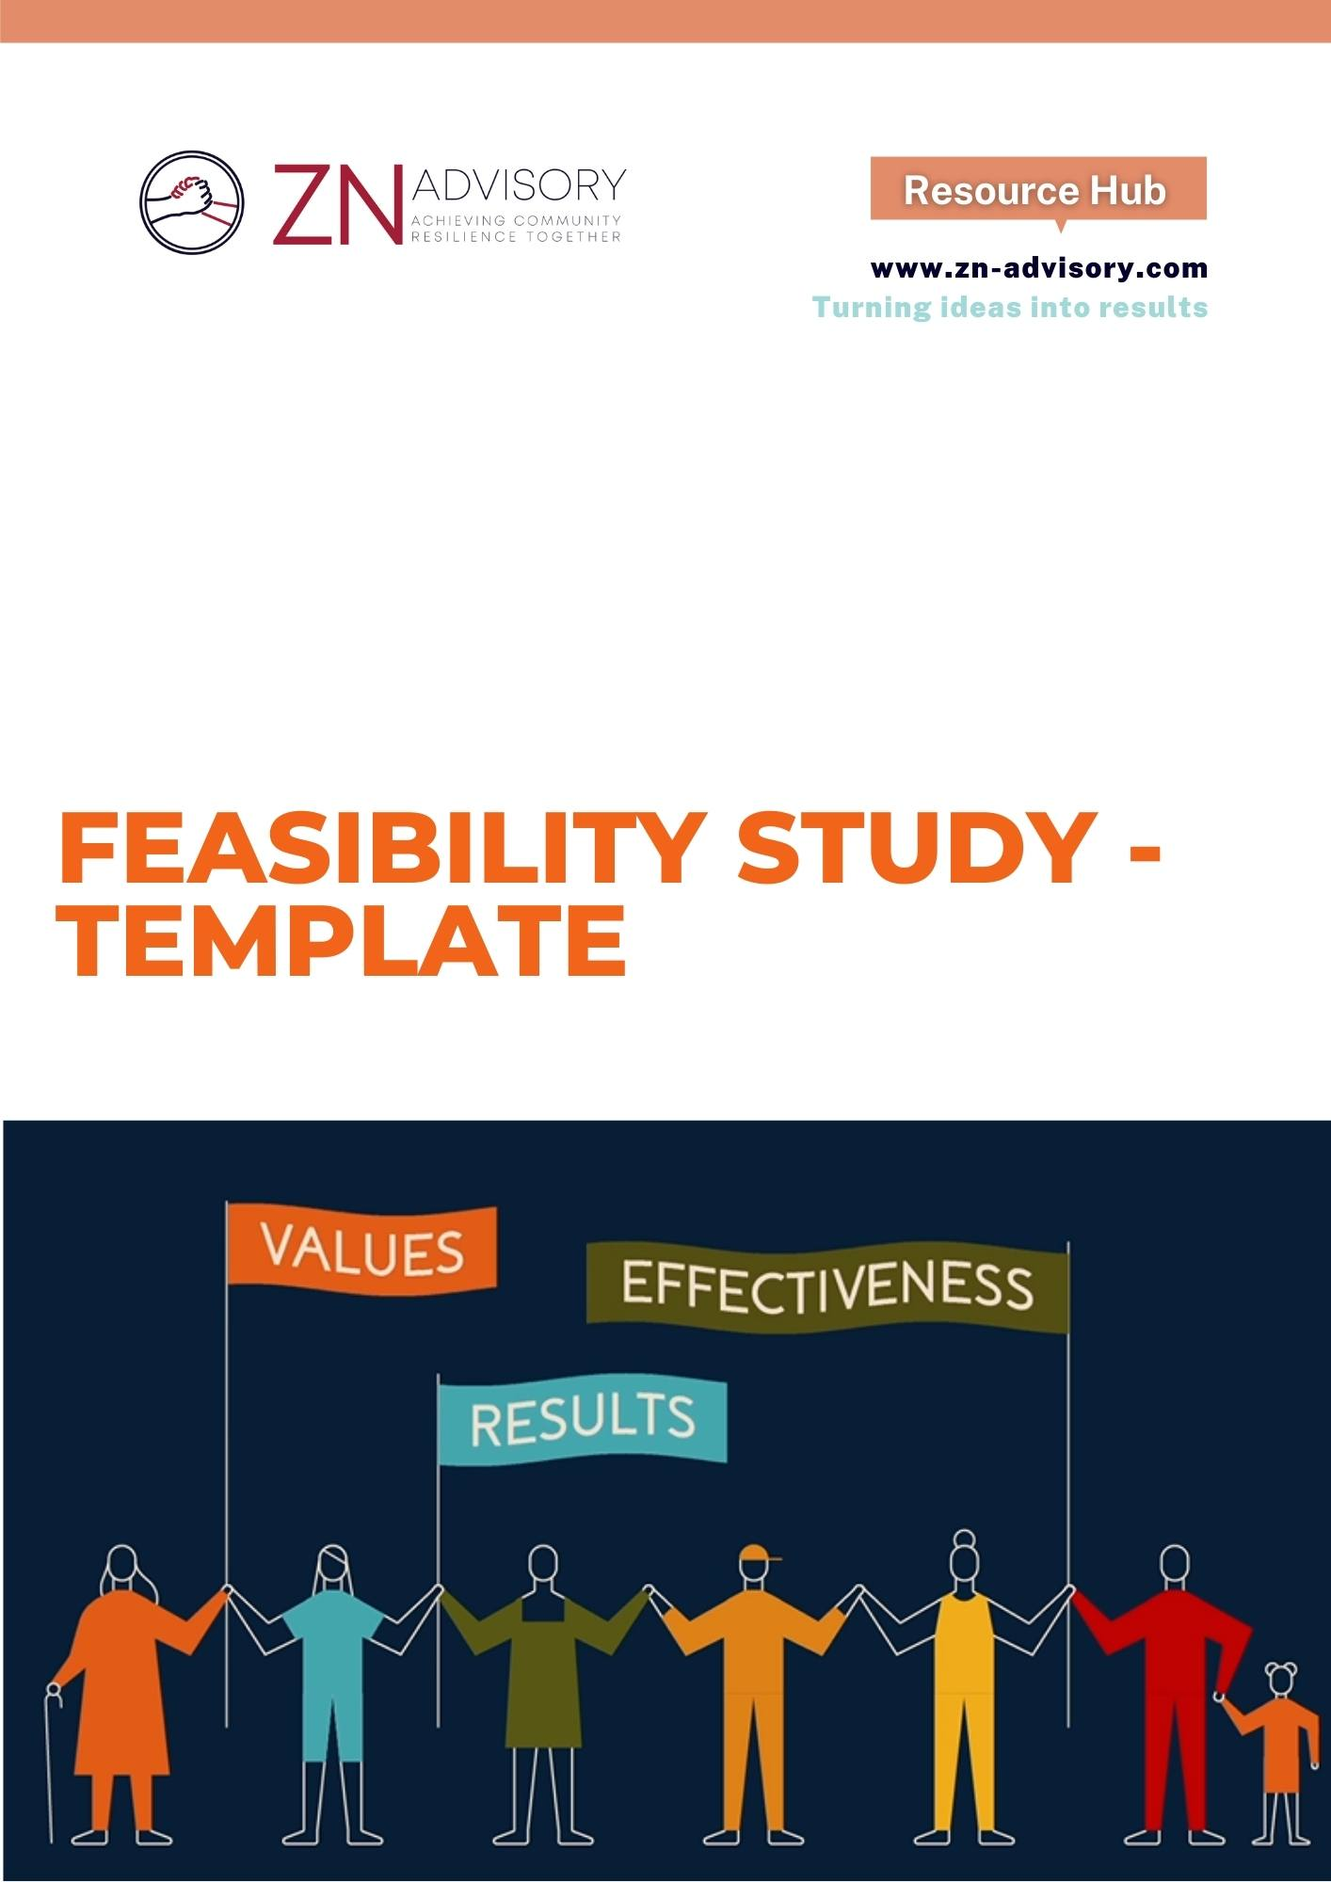
Feasibility Study Template
Purpose:
A feasibility study is conducted mainly to assess the practicality of a project. By looking at the strength and weakness of a business proposal, opportunities, and threats in the natural environment, as well as available resources to carry through. Your feasibility study evaluates the cost and potential value of a project and helps decision-makers understand whether or not to move the project forward. This template will help you understand how to develop such a study and prepare you for making the right decisions for your organization.
Introduction:
This section provides general information about the market and industry your project/organization is in. It should explain the typical mode of your business and some potential approaches for you to get into the market.
- Business and Market Overview
- What would be the typical life cycle of your business?

- What are some successful business cases you could learn from?

- What is the current market trend and your unique market placement?

- Who are those strong competitors?

- What are the different options (i.e. factory; technology; equipment; products) available for operating your business?

Operation Analysis:
The purpose of this section is to look at the direct cost (financial) and indirect cost (environmental) that would incur to setup and operate your business. You should be clear and comprehensive about any and all of the cost components throughout the process. The collective cost analysis would help inform you whether your business is going to generate positive value or not.
- Financial Assessment
- What are the total start-up costs (fixed cost) required to start your business? For example, they could include the capital costs of the land and equipment.

- What are the daily operation costs (variable cost) involved in your business? For example, they could include wages of your employees, electricity costs, and interest payments of your outstanding debt.

- How many staff would you hire to support your business management and operations? What are their roles?

- What are the possible sources of financing?

- What are your total projected revenues? What would be the break-even point?

- Social and Environmental Assessment
- What is the public perception about your business?

- What are some short-term benefits you could bring to communities? For example, your project may create employment opportunities.

- What are some long-term benefits you could create outside of your organization?

- What are some potential environmental hazards you need to consider and address before, during and after the operation of your business?

- What are the regulations/compliance requirements you need to take into consideration?

Recommendations and Next Steps:
This section provides a summary of the business options you may want to pursue and explore, based on the assessment you have conducted earlier. Once you have made some key decisions, you may proceed to include a high-level business plan to guide your business implementation.
- Identify Viable Business Options
- What are some favorable and feasible business options?

- Are you going to pursue any of the business options?

- Plan for business implementation
- Design a business plan once you have decided it’s a “GO”.

